NAME : V.Abhinav
HALL.NO : 2403A52387
Batch = 14
01.PROMPT :
i need python code ,which checks the the given string is pandrome or not , if yes print "its a palindrome " if no print "its not a palindrome" and ignore the spaces and case

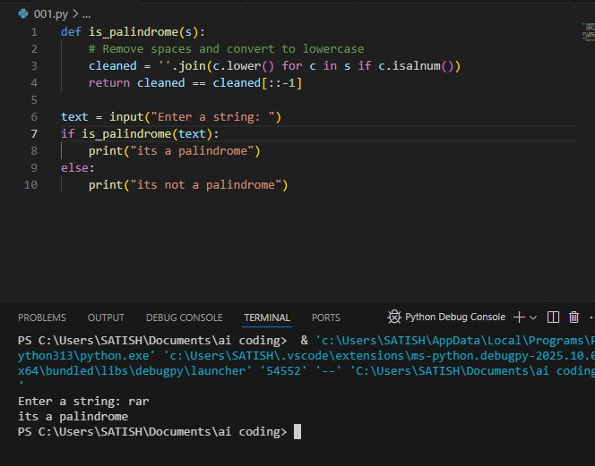
CODE AND OUTPUT :
CODE EXPLANATION :
This Python code checks if a given string is a palindrome (reads the same forward and backward):
- cleaned = ''.join(c.lower() for c in s if c.isalnum())
➤ Removes spaces/punctuation and converts letters to lowercase.
- cleaned == cleaned[::-1]
➤ Compares the cleaned string with its reverse.
- If equal, it prints "it's a palindrome", otherwise "it's not a palindrome".
02.PROMPT :
generate a python code , function that returns the fibonacci sequence up tp n terms with only a function header and docsring
CODE AND OUTPUT:
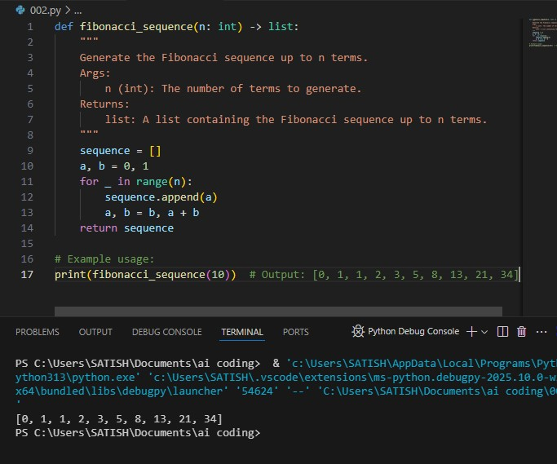

Code Explanation:
This function generates the Fibonacci sequence up to n terms:
- Starts with a = 0, b = 1 (first two Fibonacci numbers).
- In a loop, appends a to the list, then updates a, b to the next pair (b, a + b).
- Returns the list of n Fibonacci numbers.
Example:
fibonacci_sequence(10) → [0, 1, 1, 2, 3, 5, 8, 13, 21, 34]

03. PROMPT :
Give me a python code to reverse a string

CODE AND OUTPUT :
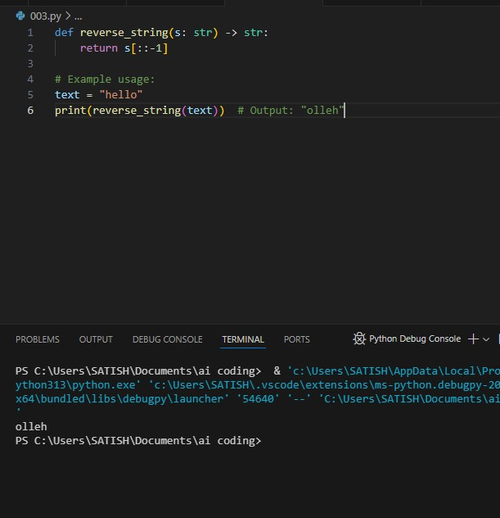

Code Explanation:
This function returns the reverse of a given string:
- s[::-1] uses slicing to reverse the string.
- Example: "hello" becomes "olleh".
04.PROMPT :
i need a python code which works like basic calculator (add , substract, divide, mltiply ) and gives output
CODE AND OUTPUT:
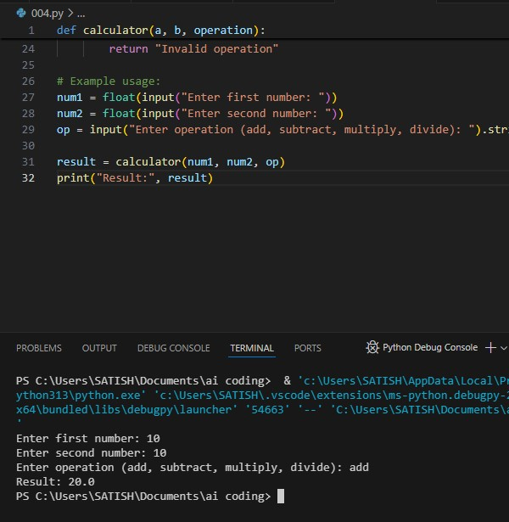

Code Explanation:
This function performs basic arithmetic operations:
- Takes two numbers (a, b) and an operation (add, subtract, multiply, divide).
- Uses if-elif to choose the correct operation.
- Checks for division by zero.
- Returns the result or an error message for invalid input.
Example:
If input is a = 5, b = 2, operation = 'add', output will be 7.
05.PROMPT :
i need a python code which reads a file and gives output number of lines
CODE AND OUTPUT:
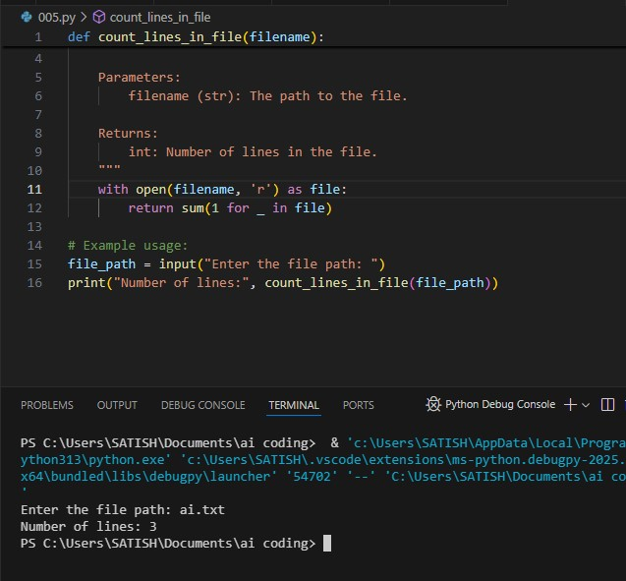

Code Explanation:
This function counts the number of lines in a file:
- Opens the file in read mode.
- Uses a generator expression to count lines with sum(1 for _ in file).
- Returns the total line count.
Example:
If a file has 10 lines, it will return 10.

